0.85 0.15 n=3

DP:

0.4566,0.4566,0.4566,0.4567,0.4567,0.4568,0.4568,0.4569,0.4568,0.4568,0.4569,0.4569,0.4569,0.4569,0.4569,0.4569,0.4569,0.4569,0.4569,0.4569,0.4569,0.4569,0.4569,0.4569,0.4569,0.4569,0.4569,0.4569,0.4569,0.4569,0.4569,0.4569,0.4569,0.4569,0.4569,0.4569,0.4569,0.4569,0.4569,0.4569,0.4569,0.4569,0.4569,0.4569,0.4569,0.4569,0.4569,0.4569,0.4569

Random:

0.4428,0.443,0.4436,0.4444,0.445,0.4457,0.4463,0.4469,0.4475,0.4476,0.4472,0.4465,0.4456,0.4444,0.4435,0.4423,0.4415,0.4406,0.4394,0.4388,0.4383,0.4383,0.4392,0.4398,0.4411,0.4419,0.4438,0.4446,0.4443,0.4416,0.4379,0.4343,0.435,0.4381,0.4425,0.4457,0.4473,0.4477,0.4474,0.4467,0.4467,0.4465,0.4466,0.447,0.447,0.4484,0.4514,0.4534,0.4542

SCS:

0.4419,0.4419,0.4419,0.4419,0.4419,0.4419,0.4419,0.4419,0.4419,0.4419,0.4419,0.4418,0.4418,0.4418,0.4419,0.4419,0.4419,0.4418,0.4419,0.4419,0.442,0.442,0.442,0.442,0.442,0.4421,0.4422,0.4423,0.4423,0.4424,0.4425,0.4426,0.4426,0.4428,0.4429,0.443,0.4432,0.4434,0.4436,0.4437,0.4438,0.4441,0.4442,0.4444,0.4446,0.4448,0.4453,0.4455,0.4459

HR:

0.4461,0.4469,0.4489,0.451,0.453,0.4547,0.4563,0.4578,0.4596,0.4604,0.4616,0.4621,0.4631,0.4634,0.464,0.4644,0.4648,0.4649,0.465,0.4648,0.4645,0.4644,0.464,0.4637,0.4633,0.4629,0.4624,0.462,0.4614,0.4609,0.4603,0.4599,0.4595,0.459,0.4584,0.458,0.4575,0.457,0.4566,0.4563,0.4561,0.4561,0.456,0.456,0.456,0.456,0.456,0.456,0.456

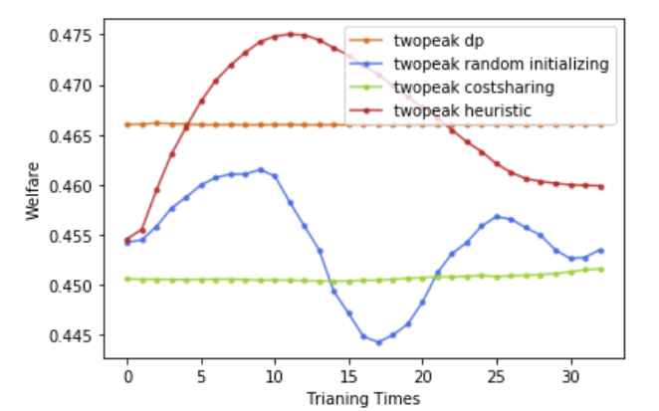

penalty 都为0，

HR 是因为 fix penalty 变化成先增后减的。